**WT PREFINAL ANSWERS**

1. **Write a program to explain about the concept of arrays in PHP**

**Ans:**

PHP array is an ordered map (contains value on the basis of key). It is used to hold multiple values of similar type in a single variable.

**PHP Array Types**

There are 3 types of array in PHP.

1. Indexed Array

2. Associative Array

3. Multidimensional Array

**Indexed Array**

PHP index is represented by number which starts from 0. We can store number, string and object in the PHP array. All PHP array elements are assigned to an index number by default.

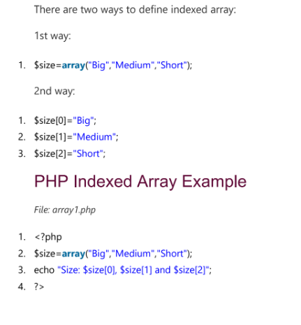

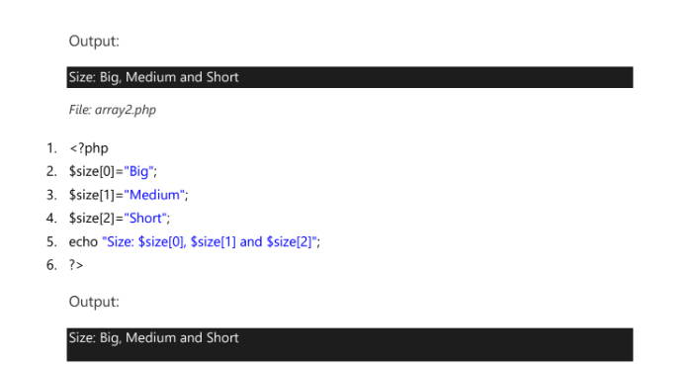

**Associative Array**

These types of arrays are similar to the indexed arrays but instead of linear storage, every value can be assigned with a user-defined key of string type. We can associate name with each array elements in PHP using => symbol.

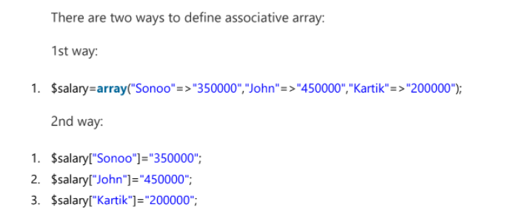

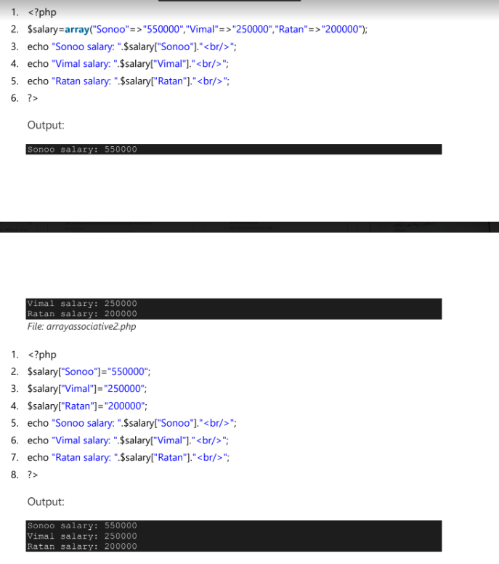

**Multidimensional Array**

PHP multidimensional array is also known as array of arrays. It allows you to store tabular data in an array. PHP multidimensional array can be represented in the form of matrix which is represented by row * column.

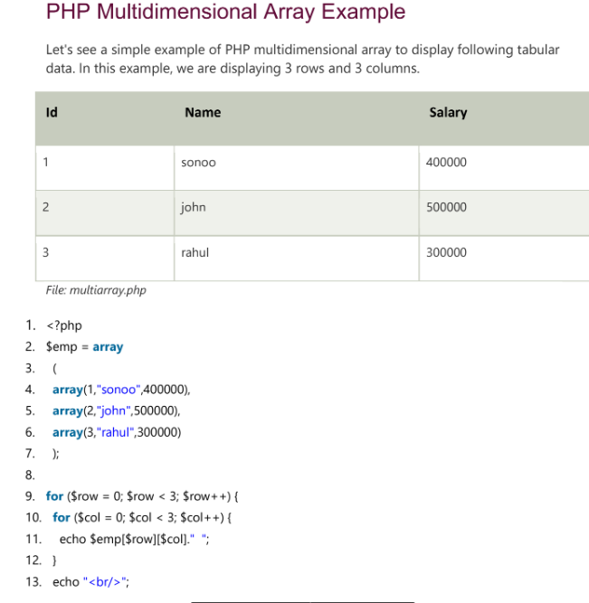

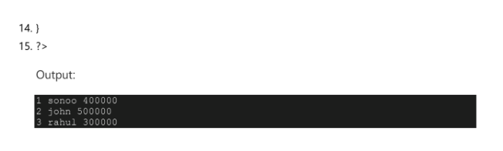

1. **Illustrate the control structures in PHP with examples.**

**Ans:**

A control structure allows you to control the flow of code execution in your application. Generally, a program is executed sequentially, line by line, and a control structure allows you to alter that flow, usually depending on certain conditions.

Control structures are core features of the PHP language that allow your script to respond differently to different inputs or situations. This could allow your script to give different responses based on user input, file contents, or some other data.

The following flowchart explains how a control structure works in PHP.

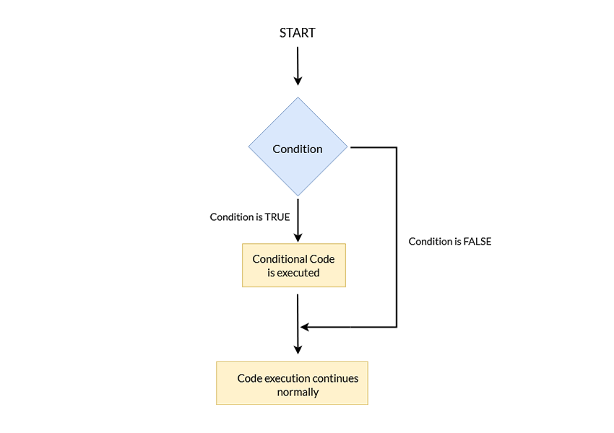

PHP supports a number of different control structures:

* if
* else
* elseif
* switch
* while
* do-while
* for
* foreach

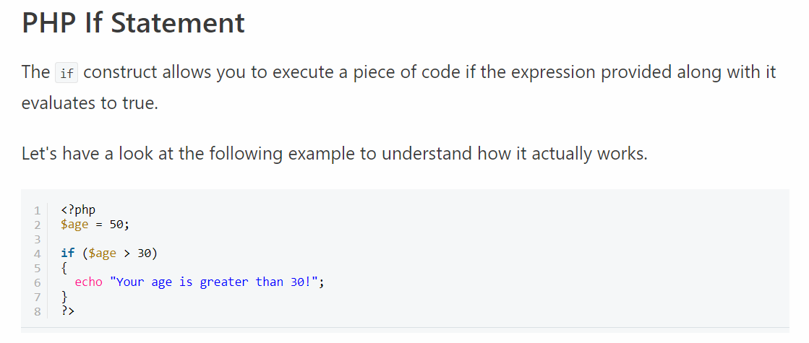

PHP ELSE Statement

 the if construct, which allows you to execute a piece of code if the expression evaluates to true. On the other hand, if the expression evaluates to false, it won't do anything.

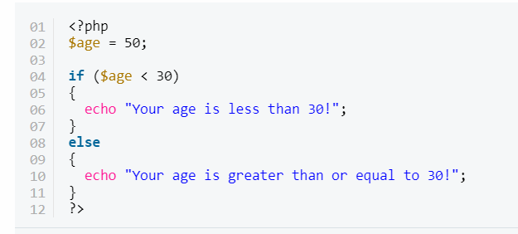

PHP Else If Statements

We can consider the elseif statement as an extension to the if-else construct. If you've got more than two choices to choose from, you can use the elseif statement.

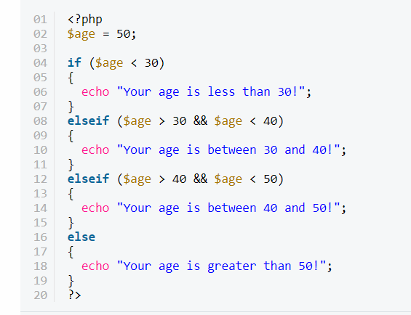

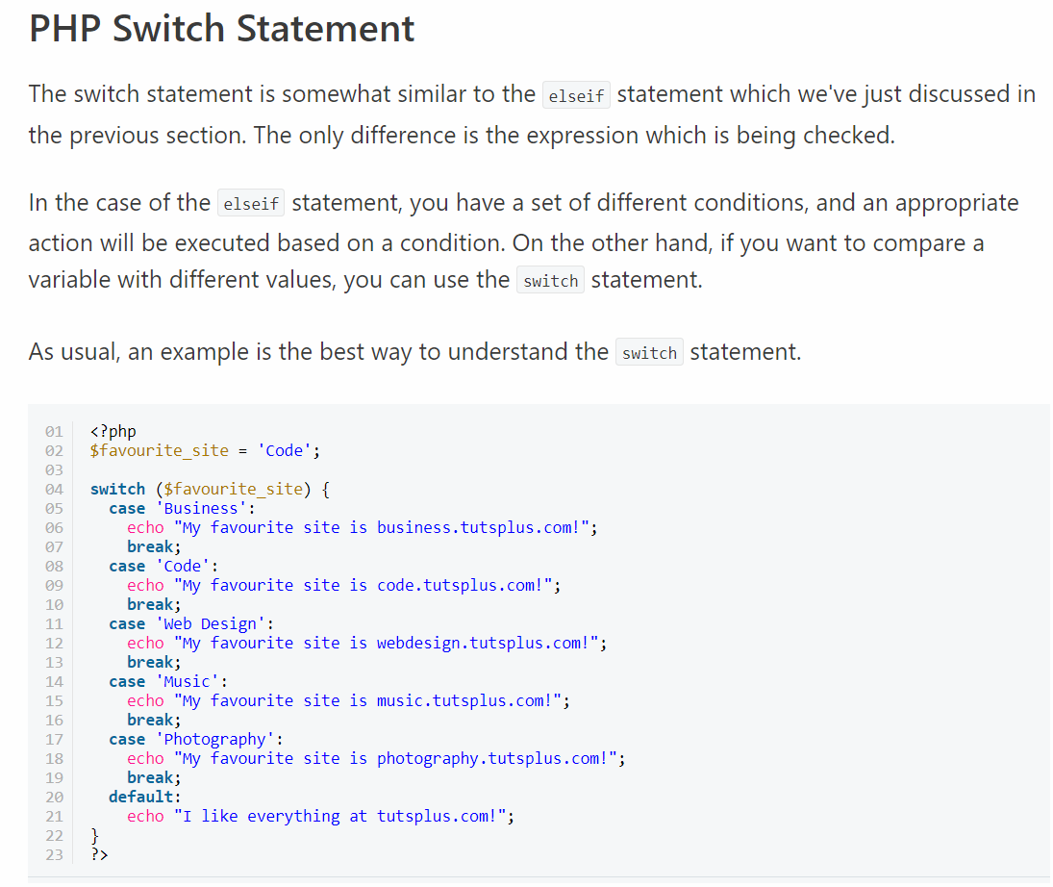

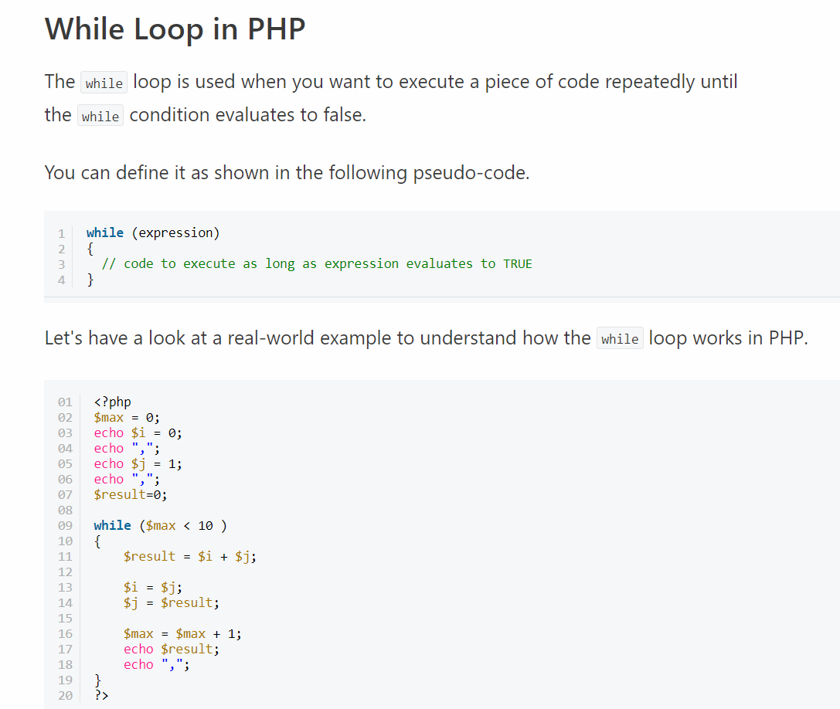

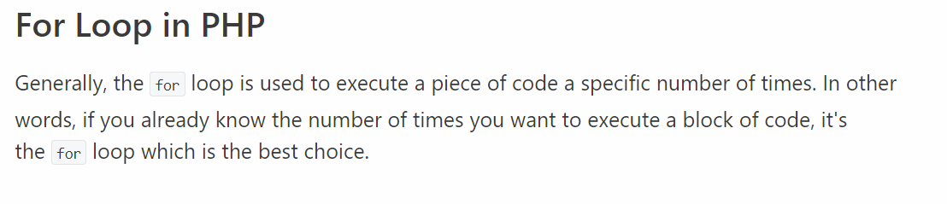

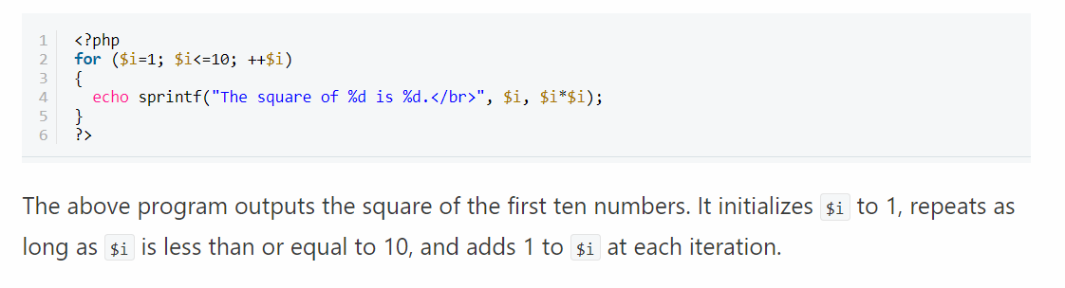

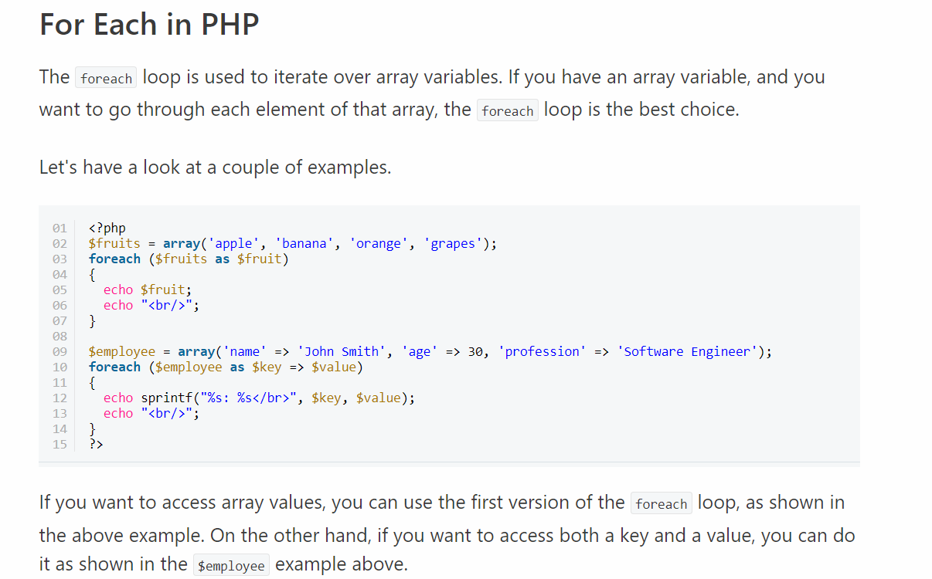

**3. Categorize various file operations on text files in PHP**

**Ans:**

* **“w” –** Opens a file for write only. If file not exist then new file is created and if file already exists then contents of file is erased.
* **“r” –** File is opened for read only.
* **“a” –** File is opened for write only. File pointer points to end of file. Existing data in file is preserved.
* **“w+” –** Opens file for read and write. If file not exist then new file is created and if file already exists then contents of file is erased.
* **“r+” –** File is opened for read/write.
* **“a+” –** File is opened for write/read. File pointer points to end of file. Existing data in file is preserved. If file is not there then new file is created.
* **“x” –** New file is created for write only.

File handling is needed for any application. For some tasks to be done file needs to be processed. File handling in PHP is similar as file handling is done by using any programming language like C. PHP has many functions to work with normal files. Those functions are:

1) **fopen() –** PHP fopen() function is used to open a file. First parameter of fopen() contains name of the file which is to be opened and second parameter tells about mode in which file needs to be opened, e.g.,

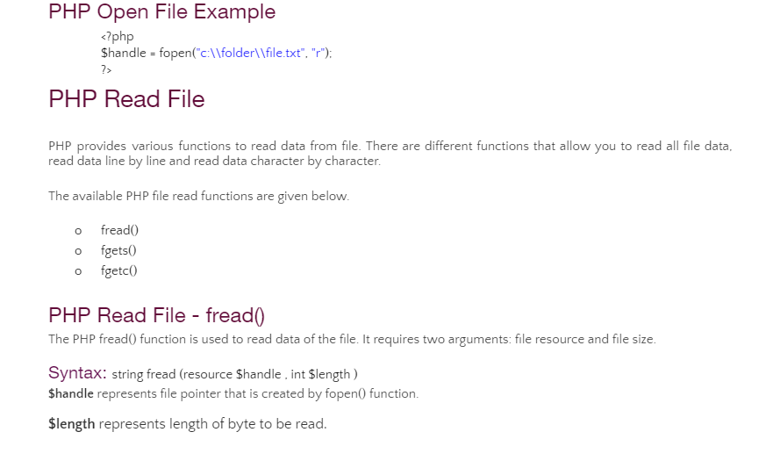

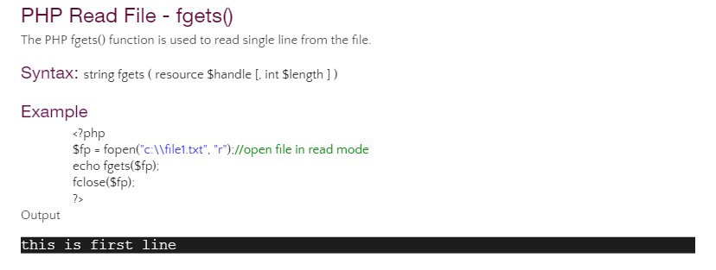

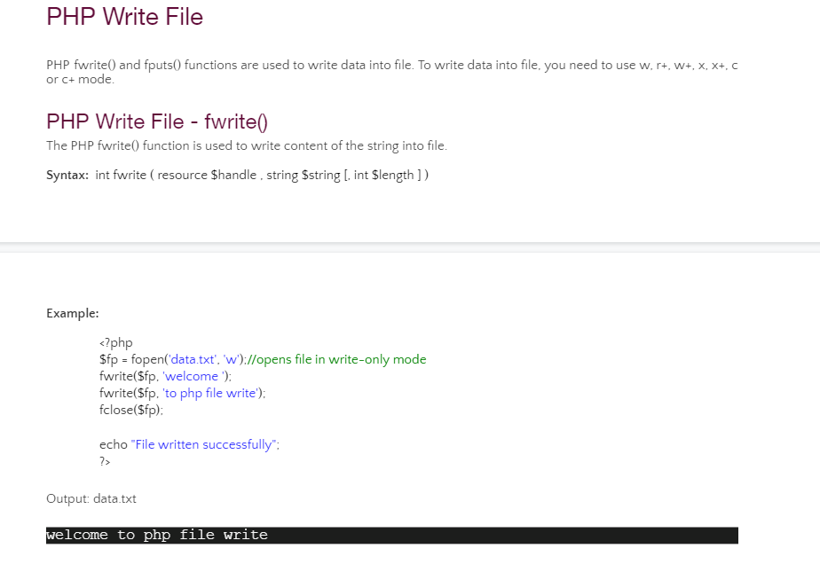

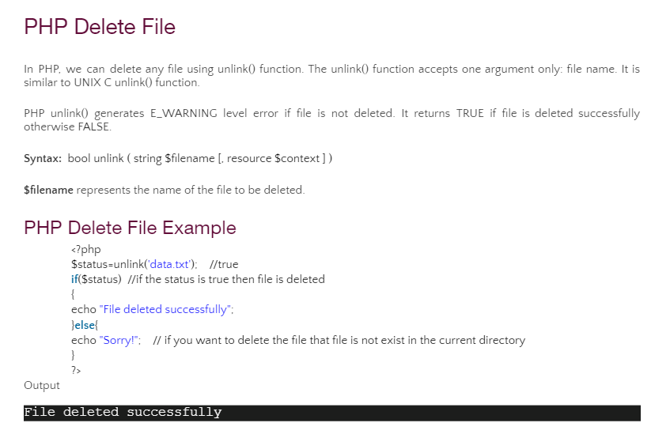

**4.Write a php program to create a form with actions, which consists of input fields as text, radio button, drop down menu and checked box**

**Ans:** <! Doctype html>

<html >

<head>

<title> PHP Registration Form Example </title>

<style> .error{color:#ff0000;}</style>

</head>

<body>

<?php

$nameErr = $genderErr = $deptErr = $favlangErr = "";

$name = $gender = $dept = $favlang= "";

if ($_SERVER["REQUEST_METHOD"] == "POST") {

if (empty($_POST["name"])) {

$nameErr = "Name Field is required";

} else {

$name = test_input($_POST["name"]);

}

if (empty($_POST["gender"])) {

$genderErr = "gender is required";

} else {

$name = test_input($_POST["gender"]);

}

if (empty($_POST["dept"])) {

$nameErr = "department is required";

} else {

$name = test_input($_POST["dept"]);

}

if (empty($_POST["favlang"])) {

$nameErr = "fav programming lang is required";

} else {

$name = test_input($_POST["fav lang"]);

}

}

function test_input($data) {

$data = trim($data);

$data = stripslashes($data);

$data = htmlspecialchars($data);

return $data;

}

?>

<h2> PHP Form Example </h2>

<p><span class="error">*required field.</span></p>

<form method="post" action="<?php echo htmlspecialchars($_SERVER["PHP_SELF"]);?>" >

<table>

<tr> <td>Enter Name: </td>

<td><input type="text" name="name">

<span class="error"> * <?php echo $nameErr;?> </span> </td></tr>

<tr><td>Enter Gender:</td><td>

<input type="radio" name="gender" value="female">FEMALE

<input type="radio" name="gender" value="male">MALE

<span class="error"> * <?php echo $genderErr;?> </span> </td></tr>

<tr> <td>Enter Dept: </td>

<select name="depts">

<option value="CSE">CSE</option>

<option value="ECE">ECE</option>

<option value="MECH">MECH</option>

<option value="IT">IT</option>

</select>

<span class="error"> * <?php echo $deptErr;?> </span>

<tr><td>Enter fav programming lang:</td>

<input type="checkbox" name="cse" value="C lang">C lang

<input type="checkbox" name="cse" value="python">python

<input type="checkbox" name="cse" value="java">java

<span class="error"> * <?php echo $favlangErr;?> </span>

</tr>

<td><input type="submit" name="submit" value="Submit "> </td>

</table>

</form>

<?php

echo "<h2> Your Input: </h2>";

echo $name; echo "<br>";

echo $gender; echo "<br>";

echo $dept; echo "<br>";

echo $favlang;

?>

</body>

</html>

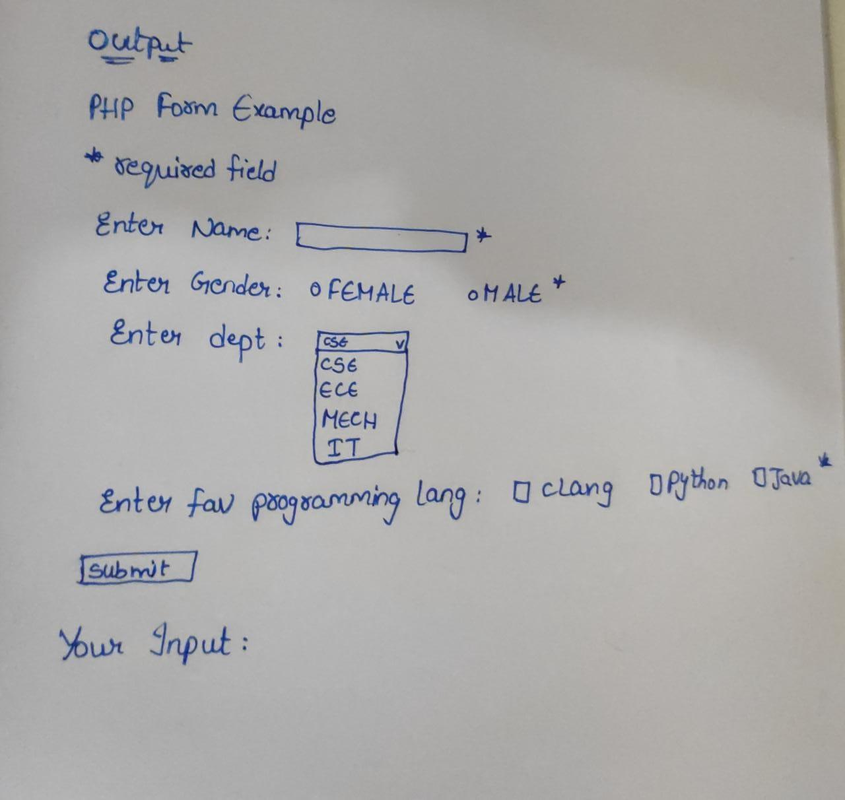

**5.Write an html program to demonstrate the working of ordered and unordered lists in html.**

**Ans:**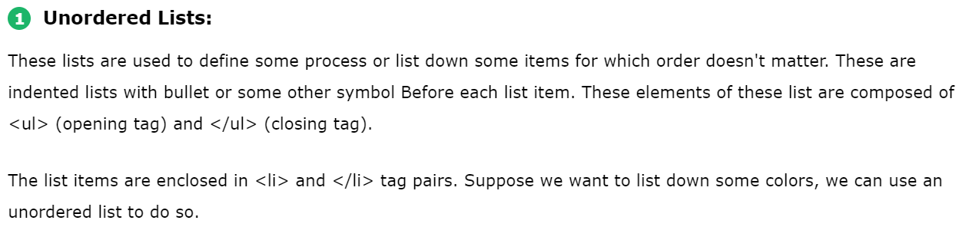

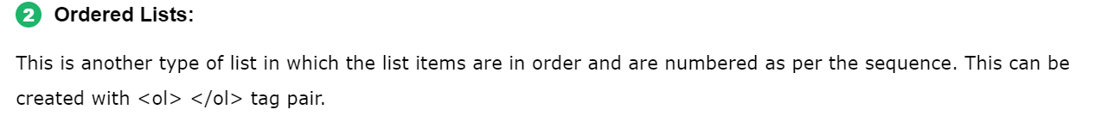

**Code:**

<!DOCTYPE html>

<html lang="en">

<head>

    <meta charset="UTF-8">

    <title>Types of Lists in HTML</title>

    <style>

    .square {

          list-style: square;

          font-size : 16px

          }

    .circle {

           list-style: circle;

           font-size: 16px

     }

</style>

</head>

<body>

<h1 style="color:blue;text-align:center;font:24px">Example for Unordered, Ordered lists </h1>

<h2 style="color:green;text-align:left;font:20px">Unordered List</h2>

<ul>

  <li>Red</li>

  <li>Black</li>

  <li>Blue</li>

</ul>

<h2 style="color:green;text-align:left;font:20px">Ordered List</h2>

<ol>

    <li>Getting up at 6</li>

    <li>Outdoor running for 45 mins</li>

    <li>Getting ready by 8</li>

    <li>Breakfast by 8:30</li>

    <li>Reach office by 9:30</li>

</ol>

</body>

</html>

**Output:**

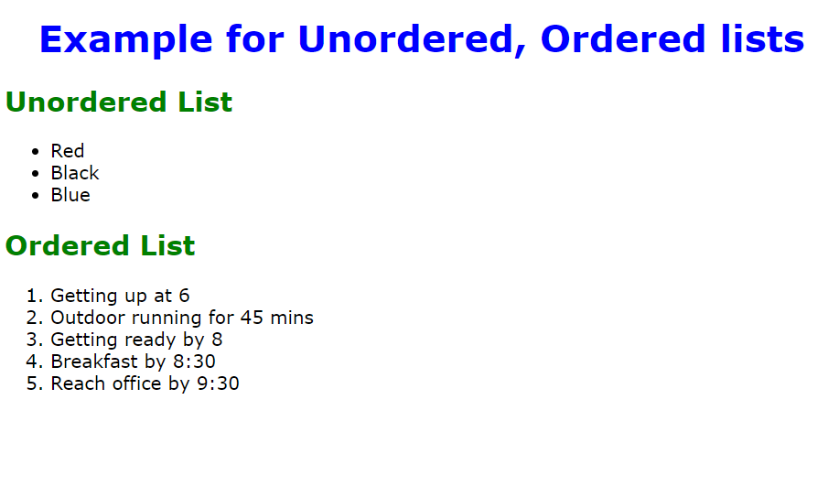

**6.** **Write a program to create an internal cascading style sheet using a) Id Selectors b) Class Selector**

**Ans:**

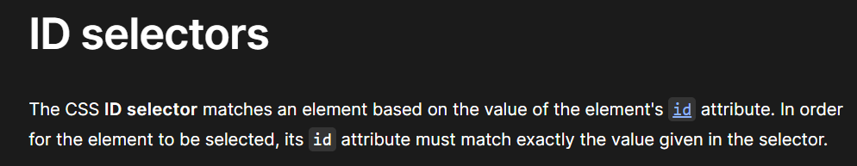

**Code:**

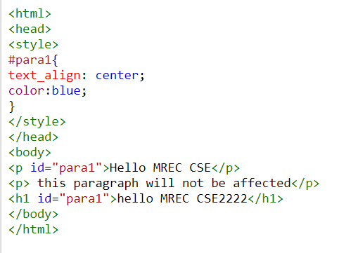

**Output:**

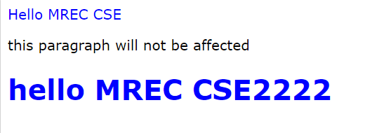

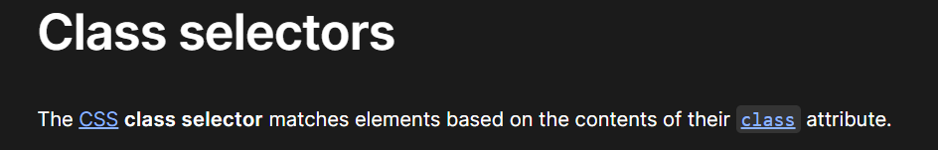

**Code:**

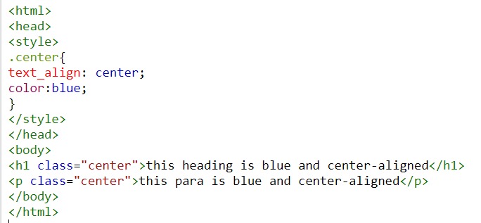

**Output:**



**7.Summarize the various types of XML parsers.**

**Ans:**

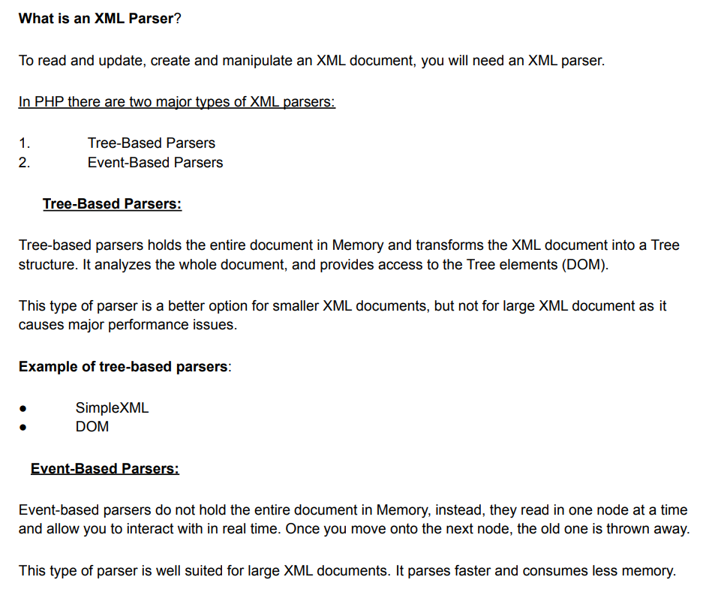

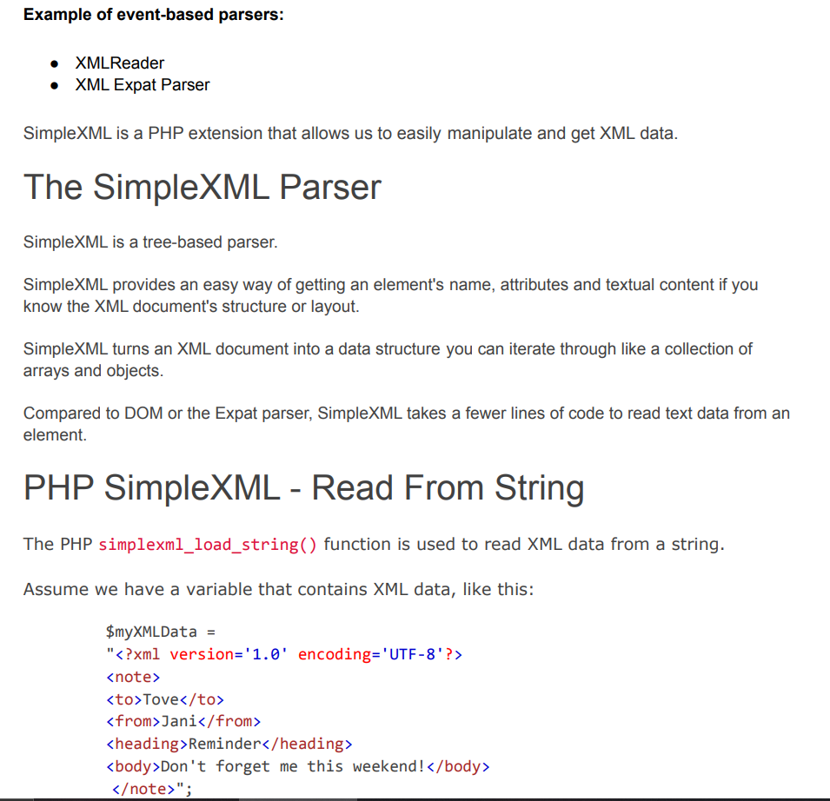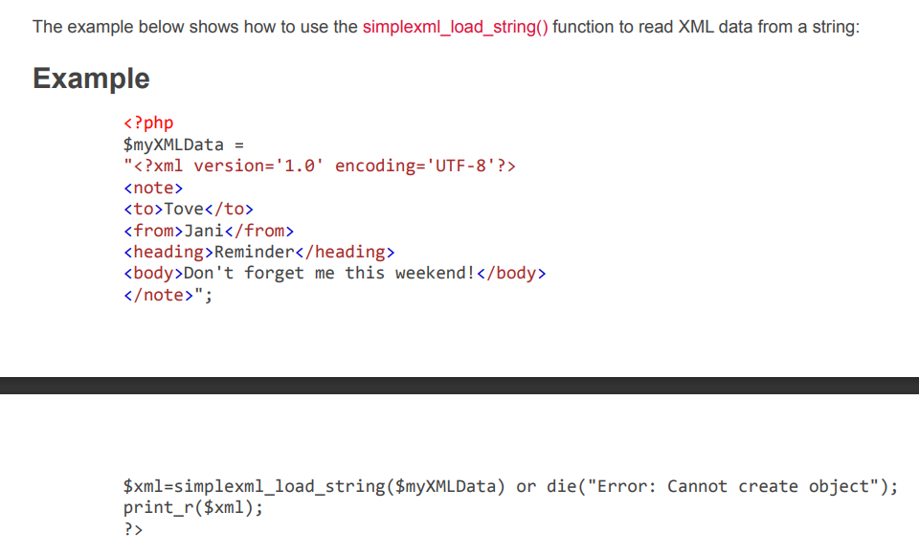

**8.Extend the features of XML namespaces and explain how are they declared?**

**Ans:**

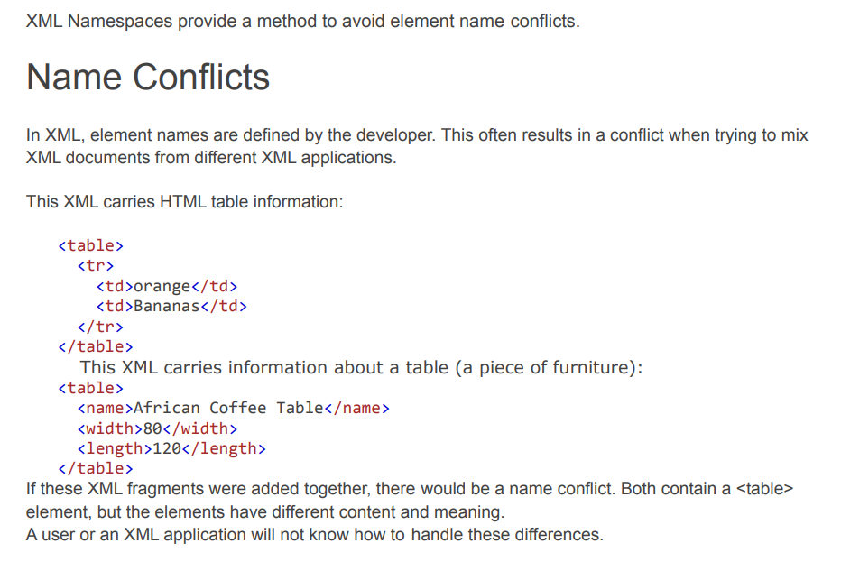

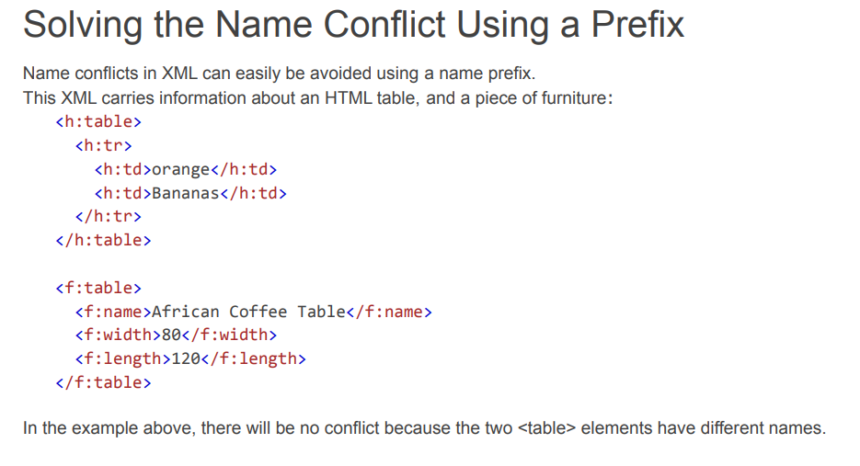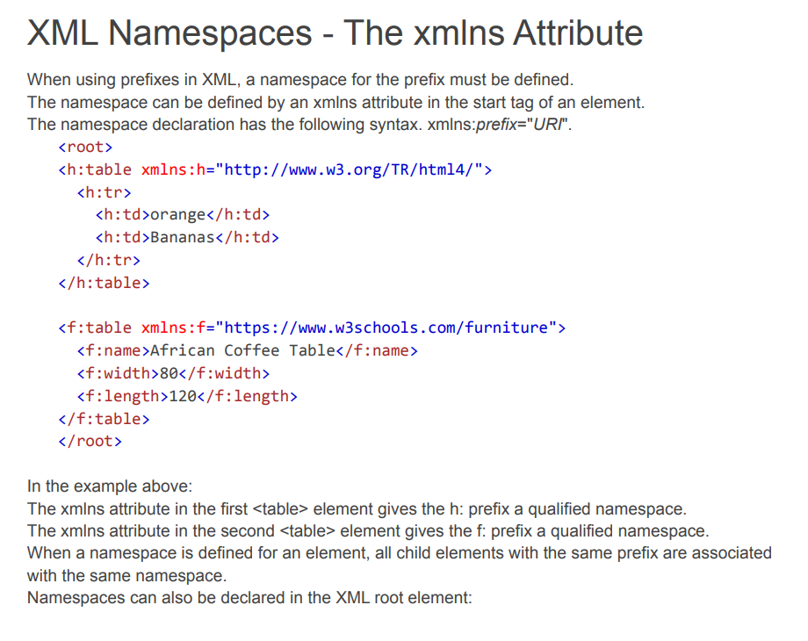

**9.** **Summarize the life cycle of a java servlet with a neat diagram**

**Ans:**

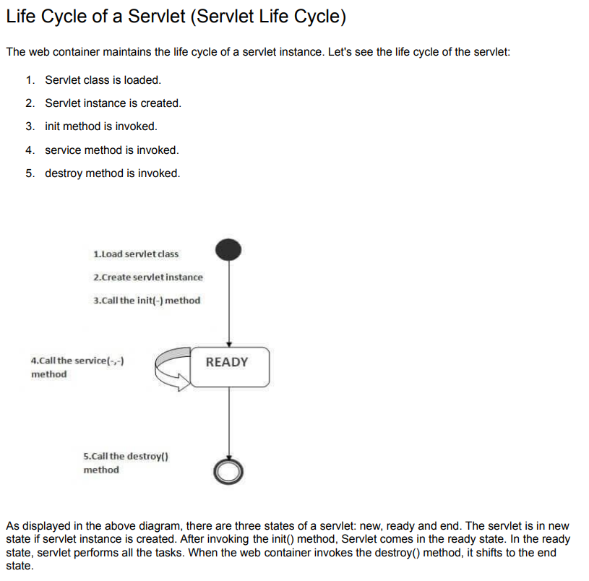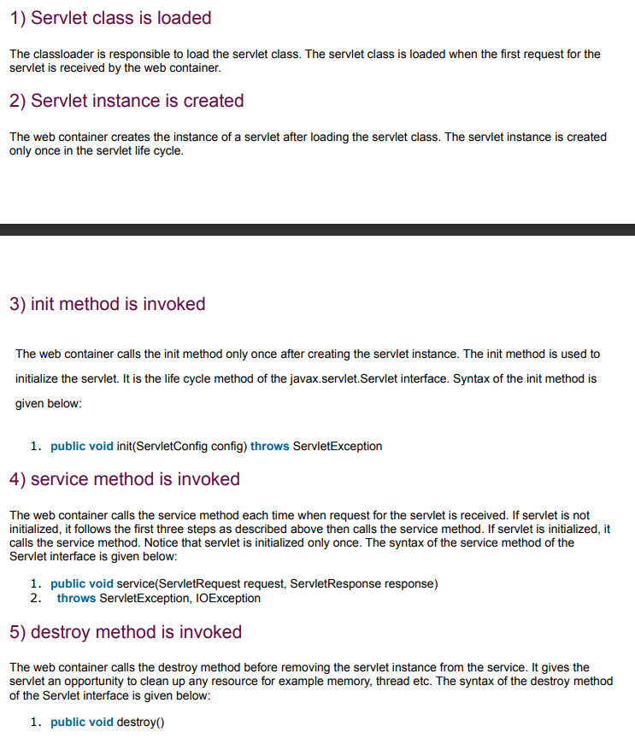

**10.** **Elaborate the differences between Generic Servlet and HttpServlet.**

**Ans:**

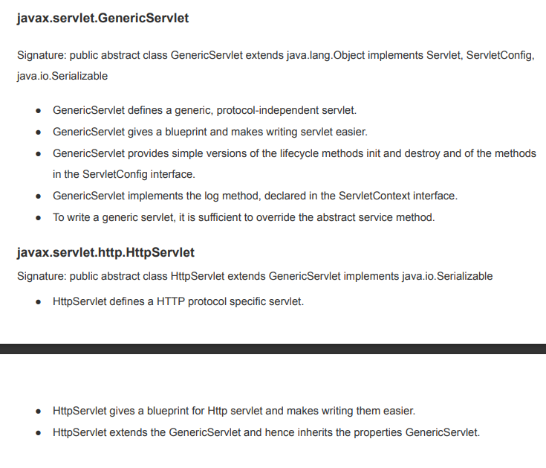

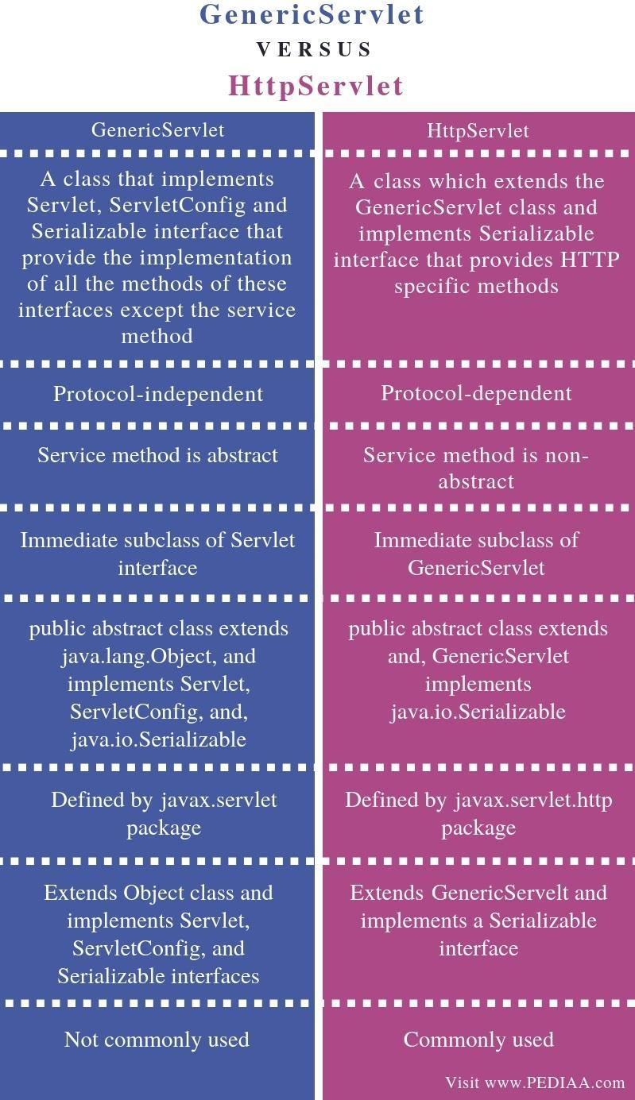

**11.** **Develop a program to demonstrate the use of cookies in servlets with an example.**

**Ans:**

index.html

1. <form action="servlet1" method="post">
2. Name:<input type="text" name="userName"/><br/>
3. <input type="submit" value="go"/>
4. </form>

### FirstServlet.java

1. **import** java.io.*;
2. **import** javax.servlet.*;
3. **import** javax.servlet.http.*;

6. **public** **class** FirstServlet **extends** HttpServlet {
8. **public** **void** doPost(HttpServletRequest request, HttpServletResponse response){
9. **try**{
11. response.setContentType("text/html");
12. PrintWriter out = response.getWriter();
14. String n=request.getParameter("userName");
15. out.print("Welcome "+n);
17. Cookie ck=**new** Cookie("uname",n);//creating cookie object
18. response.addCookie(ck);//adding cookie in the response
20. //creating submit button
21. out.print("<form action='servlet2'>");
22. out.print("<input type='submit' value='go'>");
23. out.print("</form>");
25. out.close();
27. }**catch**(Exception e){System.out.println(e);}
28. }
29. }

### SecondServlet.java

1. **import** java.io.*;
2. **import** javax.servlet.*;
3. **import** javax.servlet.http.*;
5. **public** **class** SecondServlet **extends** HttpServlet {
7. **public** **void** doPost(HttpServletRequest request, HttpServletResponse response){
8. **try**{
10. response.setContentType("text/html");
11. PrintWriter out = response.getWriter();
13. Cookie ck[]=request.getCookies();
14. out.print("Hello "+ck[0].getValue());
16. out.close();
18. }**catch**(Exception e){System.out.println(e);}
19. }
20. }

**Output:**

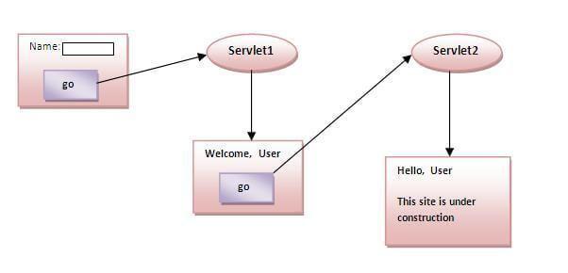

**12**. **Develop a servlet program to retrieve data from the database**.

**Ans:**

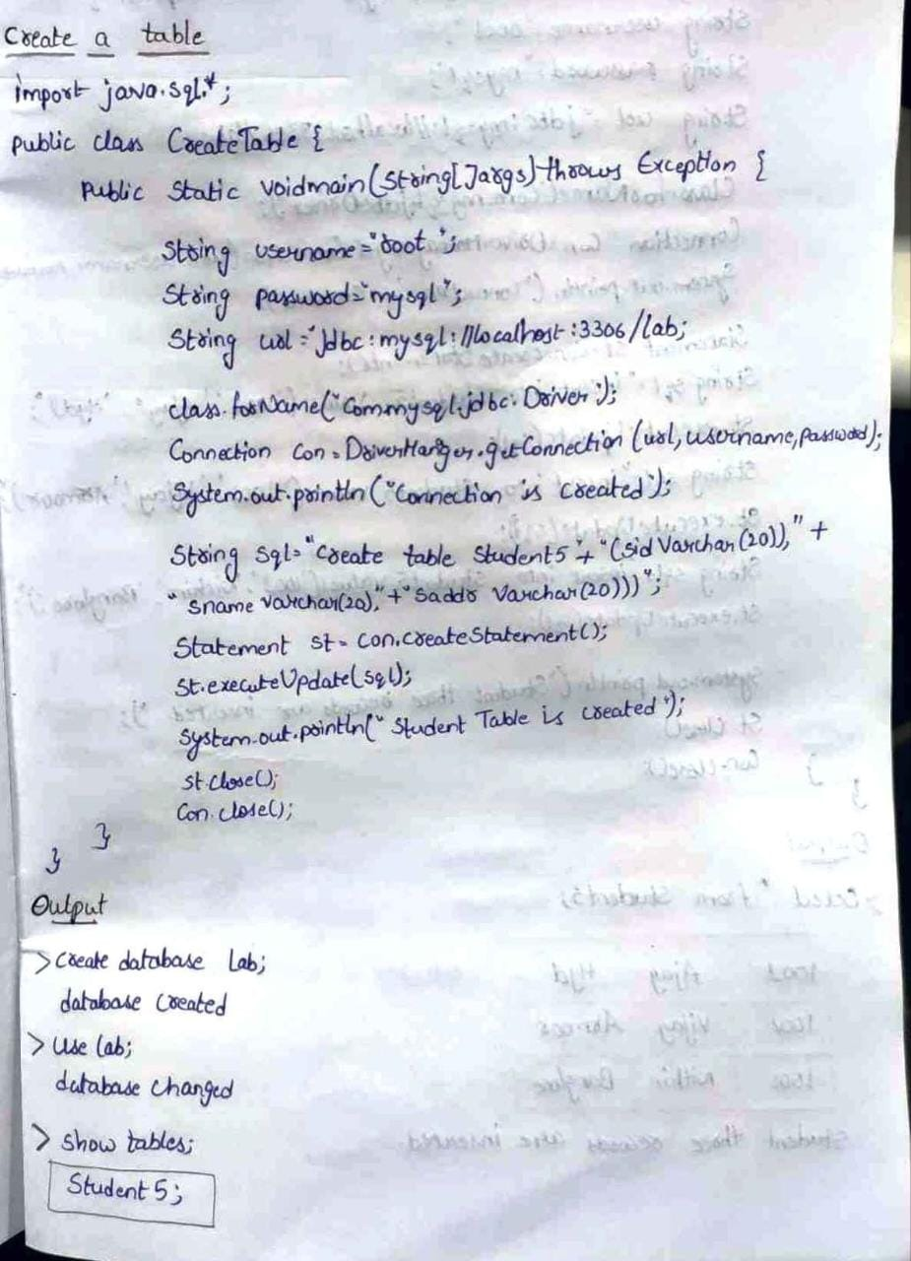

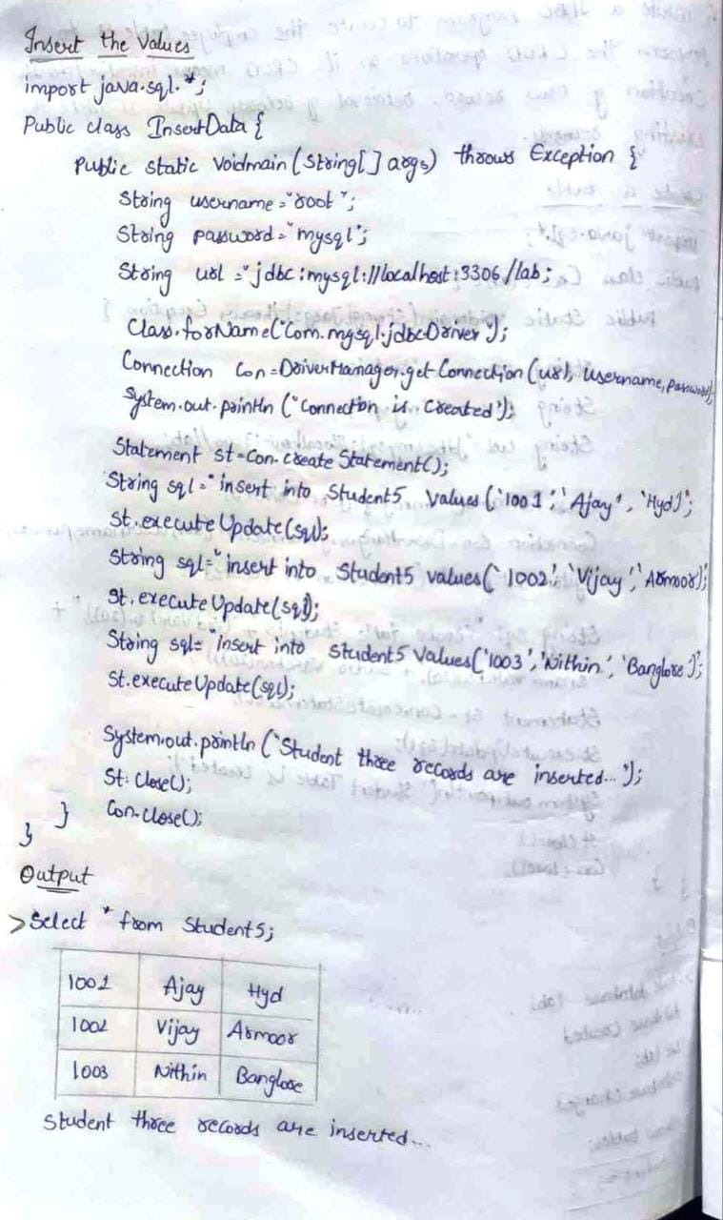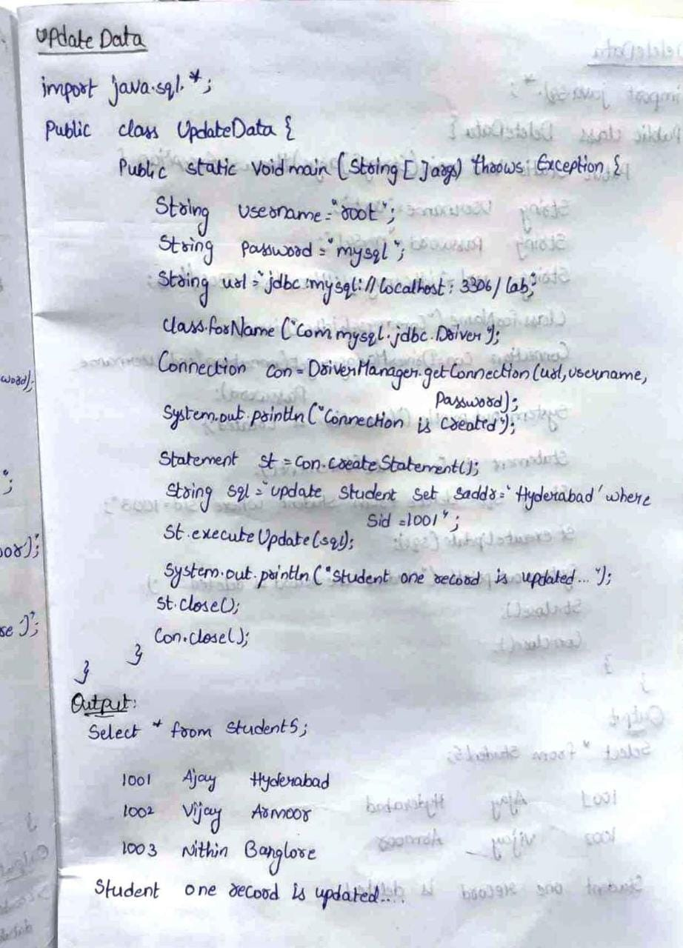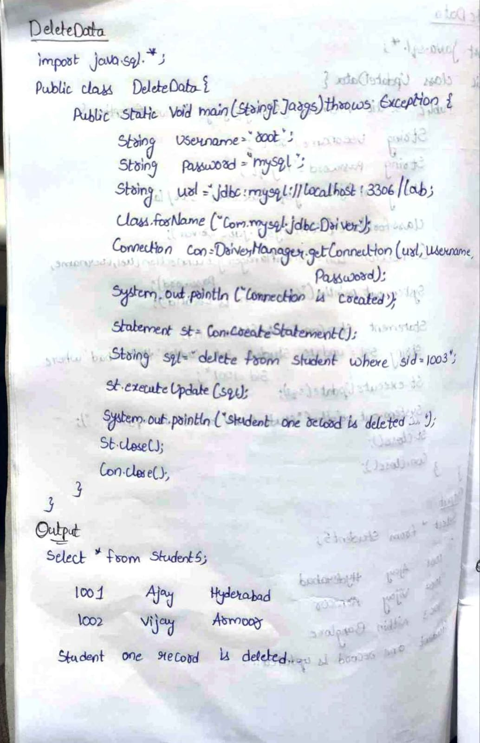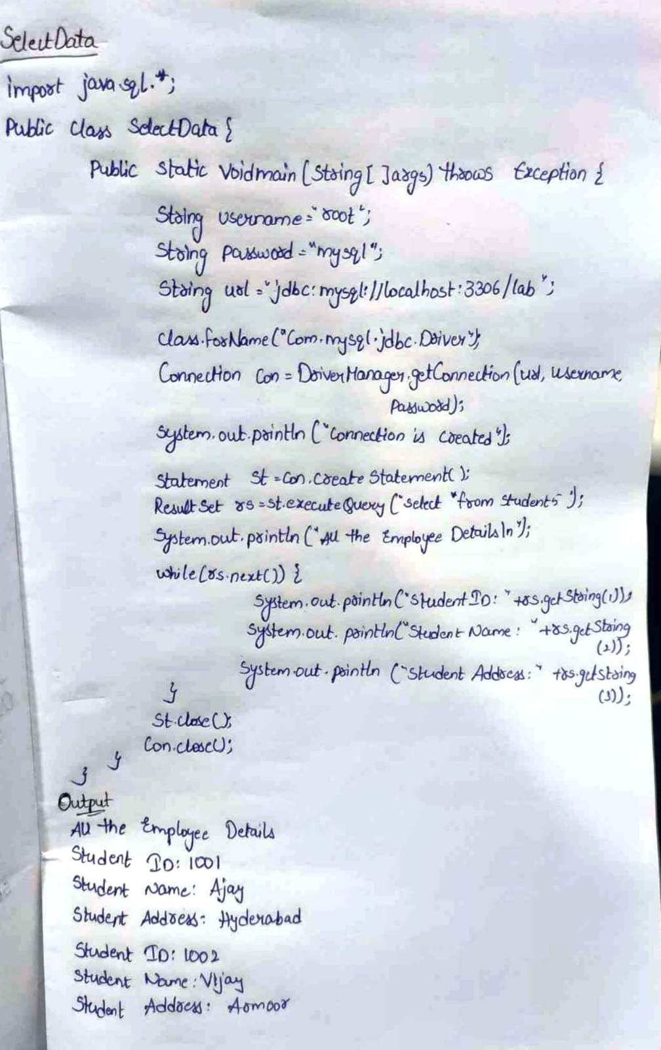

**13.** **Summarize the features of JSP tag extensions and libraries**

**Ans:**

Tag extensions or custom tags are application-defined language extensions to Java Server Pages. Some custom-tag activities relate to the tag library, whereas others relate to individual tags within the library.

The scripting elements provides the ability to insert java code inside the jsp. There are three types of scripting elements:

* scriptlet tag
* expression tag
* declaration tag

**1.scriplet tag**

A scriptlet tag is used to execute java source code in JSP. Syntax is as follows:

1. <%  java source code %>

Example of JSP scriptlet tag

In this example, we are displaying a welcome message

1. **<html>**
2. **<body>**
3. **<**% out.print("welcome to jsp"); %**>**
4. **</body>**
5. **</html>**

**Output:** welcome to jsp

**2.expression tag**

The code placed within **JSP expression tag** is *written to the output stream of the response*. So you need not write out.print() to write data. It is mainly used to print the values of variable or method.

### Syntax of JSP expression tag

1. **<**%=  statement %**>**

### Example of JSP expression tag

In this example of jsp expression tag, we are simply displaying a welcome message.

1. **<html>**
2. **<body>**
3. **<**%= "welcome to jsp" %**>**
4. **</body>**
5. **</html>**

#### **Note: Do not end your statement with semicolon in case of expression tag.**

**Output:** welcome to jsp

**3.declaration tag**

The **JSP declaration tag** is used *to declare fields and methods*.

The syntax of the declaration tag is as follows:

1. **<**%!  field or method declaration %**>**

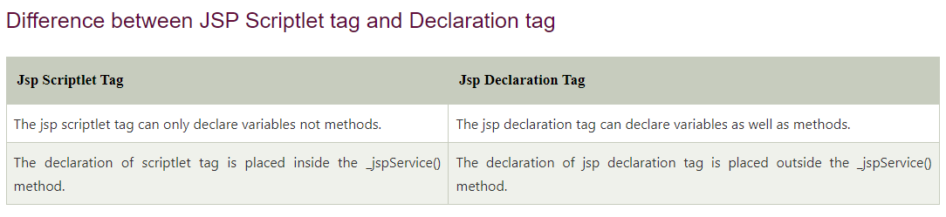**Example**

1. **<**%! int data=50; %**>**
2. **<**%= "Value of the variable is:"+data %**>**
3. **<**%!
4. int cube(int n){
5. return n*n*n*;
6. }
7. %**>**
8. **<**%= "Cube of 3 is:"+cube(3) %**>**

**Output:**

Value of the variable is: 50

Cube of 3 is: 27

1.1KC++ vs

**14. Explain how a Servlet communicate with a JSP page?**

**Ans:**

**The servlet communicate with a JSP page by**

getServletConfig().getServletContext().getRequestDispatcher(“jspfilepathtoforward”).forward(request, response);

When a servlet jsp communication is happening, it is not just about forwarding the request to a JSP from a servlet. There might be a need to transfer a string value or on object itself.

Following is a servlet and JSP source code example to perform Servlet JSP communication. Wherein an object will be communicated to a JSP from a Servlet.

## Following are the steps in Servlet JSP Communication:

1. Servlet instantiates a bean and initializes it.  
2. The bean is then placed into the request  
3. The call is then forwarded to the JSP page, using request dispatcher.

Example Servlet Source Code: (ServletToJSP.java)

public class ServletToJSP extends HttpServlet {

public void doGet(HttpServletRequest request, HttpServletResponse response) throws ServletException, IOException {

//communicating a simple String message.

String message = "Example source code of Servlet to JSP communication.";

request.setAttribute("message", message);

//communicating a Vector object

Vector vecObj = new Vector();

vecObj.add("Servlet to JSP communicating an object");

request.setAttribute("vecBean",vecObj);

//Servlet JSP communication

RequestDispatcher reqDispatcher = getServletConfig().getServletContext().getRequestDispatcher("/jsp/javaPapers.jsp");

reqDispatcher.forward(request,response);

}

}

Example JSP Source Code: (javaPapers.jsp)

<html>

<body>

<%

String message = (String) request.getAttribute("message");

out.println("Servlet communicated message to JSP: "+ message);

Vector vecObj = (Vector) request.getAttribute("vecBean");

out.println("Servlet to JSP communication of an object: "+vecObj.get(0));

%>

</body>

</html>

**15.** **Elaborate the features of JSP processing.**

**Ans:**

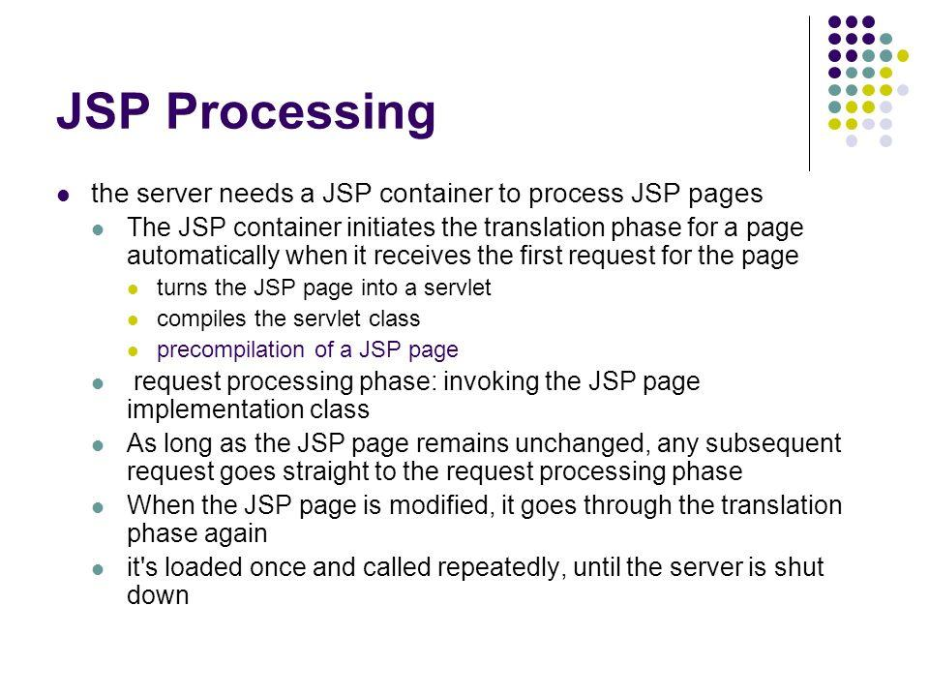

JSP are tag based approach to develop dynamic web application. JSP have all the features of Servlet because it is internally Servlet. It have following feature these are

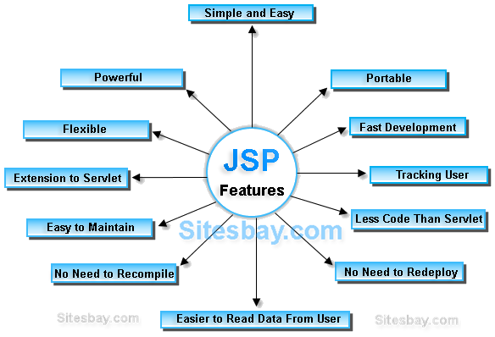

**Extension to Servlet:**JSP is Extension to Servlet, it have all the features of servlet and it have also implicit objects, predefined tags, expression language and Custom tags in JSP, that makes JSP easy to develop any application.

**Powerful:**These are internally Servlet, means consists byte code, so that all java features are applicable in case of jsp like robust, dynamic, secure, platform independent.

**Portable:**JSP tags will process and execute by the server side web container, So that these are browser independent and j2ee server independent.

**Flexible:**Allows to defined custom tags, the developer can fill conferrable to use any kind, framework based markup tags in JSP.

**Easy:**JSP is easy to learn, easy to understand and easy to develop. JSPs are more convenient to write than Servlets because they allow you to embed Java code directly into your HTML pages, in case of servlets you embed HTML inside of Java code.

**Less code than Servlet:**In JSP, we can use a lot of tags such as action tags, jstl, custom tags etc. that reduces the code.

**16.Discuss how to access a database from a JSP? Explain in detail**

**Ans:** Java Server Pages (JSP) is a server-side programming technology that enables the creation of dynamic, platform-independent method for building Web-based applications. JSP have access to the entire family of Java APIs, including the JDBC API to access enterprise databases.

To access a database from a jsp (same as jdbc):

## **Create Table**

To create the **Employees** table in the EMP database, use the following steps −

### Step 1

Open a **Command Prompt** and change to the installation directory as follows −

C:\>

C:\>cd Program Files\MySQL\bin

C:\Program Files\MySQL\bin>

### Step 2

Login to the database as follows −

C:\Program Files\MySQL\bin>mysql -u root -p

Enter password: ********

mysql>

### Step 3

Create the **Employee** table in the **TEST** database as follows − −

mysql> use TEST;

mysql> create table Employees

(

id int not null,

age int not null,

first varchar (255),

last varchar (255)

);

Query OK, 0 rows affected (0.08 sec)

mysql>

## **Create Data Records**

Let us now create a few records in the **Employee** table as follows − −

mysql> INSERT INTO Employees VALUES (100, 18, 'Zara', 'Ali');

Query OK, 1 row affected (0.05 sec)

mysql> INSERT INTO Employees VALUES (101, 25, 'Mahnaz', 'Fatma');

Query OK, 1 row affected (0.00 sec)

mysql> INSERT INTO Employees VALUES (102, 30, 'Zaid', 'Khan');

Query OK, 1 row affected (0.00 sec)

mysql> INSERT INTO Employees VALUES (103, 28, 'Sumit', 'Mittal');

Query OK, 1 row affected (0.00 sec)

mysql>

## **SELECT Operation**

Following example shows how we can execute the **SQL SELECT** statement using JTSL in JSP programming −

<%@ page import = "java.io.*,java.util.*,java.sql.*"%>

<%@ page import = "javax.servlet.http.*,javax.servlet.*" %>

<%@ taglib uri="http://java.sun.com/jsp/jstl/core" prefix = "c"%>

<%@ taglib uri="http://java.sun.com/jsp/jstl/sql" prefix = "sql"%>

<html>

<head>

<title>SELECT Operation</title>

</head>

<body>

<sql:setDataSource var = "snapshot" driver = "com.mysql.jdbc.Driver"

url = "jdbc:mysql://localhost/TEST"

user = "root" password = "pass123"/>

<sql:query dataSource = "${snapshot}" var = "result">

SELECT * from Employees;

</sql:query>

<table border = "1" width = "100%">

<tr>

<th>Emp ID</th>

<th>First Name</th>

<th>Last Name</th>

<th>Age</th>

</tr>

<c:forEach var = "row" items = "${result.rows}">

<tr>

<td><c:out value = "${row.id}"/></td>

<td><c:out value = "${row.first}"/></td>

<td><c:out value = "${row.last}"/></td>

<td><c:out value = "${row.age}"/></td>

</tr>

</c:forEach>

</table>

</body>

</html>

Access the above JSP, the following result will be displayed −

| **Emp ID** | **First Name** | **Last Name** | **Age** |
| --- | --- | --- | --- |
| 100 | Zara | Ali | 18 |
| 101 | Mahnaz | Fatma | 25 |
| 102 | Zaid | Khan | 30 |
| 103 | Sumit | Mittal | 28 |

## **INSERT Operation**

Following example shows how we can execute the SQL INSERT statement using JTSL in JSP programming −

<%@ page import = "java.io.*,java.util.*,java.sql.*"%>

<%@ page import = "javax.servlet.http.*,javax.servlet.*" %>

<%@ taglib uri="http://java.sun.com/jsp/jstl/core" prefix = "c"%>

<%@ taglib uri="http://java.sun.com/jsp/jstl/sql" prefix = "sql"%>

<html>

<head>

<title>JINSERT Operation</title>

</head>

<body>

<sql:setDataSource var = "snapshot" driver = "com.mysql.jdbc.Driver"

url = "jdbc:mysql://localhost/TEST"

user = "root" password = "pass123"/>

<sql:update dataSource = "${snapshot}" var = "result">

INSERT INTO Employees VALUES (104, 2, 'Nuha', 'Ali');

</sql:update>

<sql:query dataSource = "${snapshot}" var = "result">

SELECT * from Employees;

</sql:query>

<table border = "1" width = "100%">

<tr>

<th>Emp ID</th>

<th>First Name</th>

<th>Last Name</th>

<th>Age</th>

</tr>

<c:forEach var = "row" items = "${result.rows}">

<tr>

<td><c:out value = "${row.id}"/></td>

<td><c:out value = "${row.first}"/></td>

<td><c:out value = "${row.last}"/></td>

<td><c:out value = "${row.age}"/></td>

</tr>

</c:forEach>

</table>

</body>

</html>

Access the above JSP, the following result will be displayed −

| **Emp ID** | **First Name** | **Last Name** | **Age** |
| --- | --- | --- | --- |
| 100 | Zara | Ali | 18 |
| 101 | Mahnaz | Fatma | 25 |
| 102 | Zaid | Khan | 30 |
| 103 | Sumit | Mittal | 28 |
| 104 | Nuha | Ali | 2 |

## **DELETE Operation**

Following example shows how we can execute the **SQL DELETE** statement using JTSL in JSP programming −

<%@ page import = "java.io.*,java.util.*,java.sql.*"%>

<%@ page import = "javax.servlet.http.*,javax.servlet.*" %>

<%@ taglib uri="http://java.sun.com/jsp/jstl/core" prefix = "c"%>

<%@ taglib uri="http://java.sun.com/jsp/jstl/sql" prefix = "sql"%>

<html>

<head>

<title>DELETE Operation</title>

</head>

<body>

<sql:setDataSource var = "snapshot" driver = "com.mysql.jdbc.Driver"

url = "jdbc:mysql://localhost/TEST"

user = "root" password = "pass123"/>

<c:set var = "empId" value = "103"/>

<sql:update dataSource = "${snapshot}" var = "count">

DELETE FROM Employees WHERE Id = ?

<sql:param value = "${empId}" />

</sql:update>

<sql:query dataSource = "${snapshot}" var = "result">

SELECT * from Employees;

</sql:query>

<table border = "1" width = "100%">

<tr>

<th>Emp ID</th>

<th>First Name</th>

<th>Last Name</th>

<th>Age</th>

</tr>

<c:forEach var = "row" items = "${result.rows}">

<tr>

<td><c:out value = "${row.id}"/></td>

<td><c:out value = "${row.first}"/></td>

<td><c:out value = "${row.last}"/></td>

<td><c:out value = "${row.age}"/></td>

</tr>

</c:forEach>

</table>

</body>

</html>

Access the above JSP, the following result will be displayed −

| **Emp ID** | **First Name** | **Last Name** | **Age** |
| --- | --- | --- | --- |
| 100 | Zara | Ali | 18 |
| 101 | Mahnaz | Fatma | 25 |
| 102 | Zaid | Khan | 30 |

## **UPDATE Operation**

Following example shows how we can execute the **SQL UPDATE** statement using JTSL in JSP programming −

<%@ page import = "java.io.*,java.util.*,java.sql.*"%>

<%@ page import = "javax.servlet.http.*,javax.servlet.*" %>

<%@ taglib uri = "http://java.sun.com/jsp/jstl/core" prefix = "c"%>

<%@ taglib uri = "http://java.sun.com/jsp/jstl/sql" prefix = "sql"%>

<html>

<head>

<title>DELETE Operation</title>

</head>

<body>

<sql:setDataSource var = "snapshot" driver = "com.mysql.jdbc.Driver"

url = "jdbc:mysql://localhost/TEST"

user = "root" password = "pass123"/>

<c:set var = "empId" value = "102"/>

<sql:update dataSource = "${snapshot}" var = "count">

UPDATE Employees SET WHERE last = 'Ali'

<sql:param value = "${empId}" />

</sql:update>

<sql:query dataSource = "${snapshot}" var = "result">

SELECT * from Employees;

</sql:query>

<table border = "1" width = "100%">

<tr>

<th>Emp ID</th>

<th>First Name</th>

<th>Last Name</th>

<th>Age</th>

</tr>

<c:forEach var = "row" items = "${result.rows}">

<tr>

<td><c:out value = "${row.id}"/></td>

<td><c:out value = "${row.first}"/></td>

<td><c:out value = "${row.last}"/></td>

<td><c:out value = "${row.age}"/></td>

</tr>

</c:forEach>

</table>

</body>

</html>

Access the above JSP, the following result will be displayed −

| **Emp ID** | **First Name** | **Last Name** | **Age** |
| --- | --- | --- | --- |
| 100 | Zara | Ali | 18 |
| 101 | Mahnaz | Fatma | 25 |
| 102 | Zaid | Ali | 30 |

**17.Write a Java script programs to display array of student names**

**Ans:**

**JavaScript array** is an object that represents a collection of similar type of elements.

There are 3 ways to construct array in JavaScript

1. By array literal
2. By creating instance of Array directly (using new keyword)
3. By using an Array constructor (using new keyword)

**Example:**

<!DOCTYPE html>

<html>

<head> </head>

<body>

<center><h1>GeeksforGeeks</h1></center>

<ul id="myList"></ul>

<script>

let data = ["Ram", "Shyam", "Sita", "Gita"];

let list = document.getElementById("myList");

data.forEach((item) => {

let li = document.createElement("li");

li.innerText = item;

list.appendChild(li);

});

</script>

</body>

</html>

**Output:**

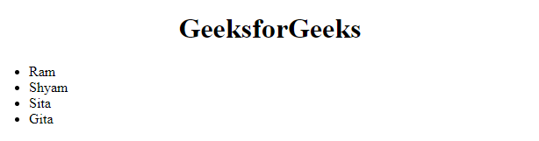

**18.Explain about object, methods and events in Java Scripts.**

**Ans:**

# **JavaScript Objects**

A javaScript object is an entity having state and behavior (properties and method). For example: car, pen, bike, chair, glass, keyboard, monitor etc.

JavaScript is an object-based language. Everything is an object in JavaScript.

JavaScript is template based not class based. Here, we don't create class to get the object. But, we direct create objects.

## **Creating Objects in JavaScript**

There are 3 ways to create objects.

1. By object literal
2. By creating instance of Object directly (using new keyword)
3. By using an object constructor (using new keyword)

## **1) JavaScript Object by object literal**

The syntax of creating object using object literal is given below:

1. object={property1:value1,property2:value2.....propertyN:valueN}

Let’s see the simple example of creating object in JavaScript.

1. **<script>**
2. emp={id:102,name:"Shyam Kumar",salary:40000}
3. document.write(emp.id+" "+emp.name+" "+emp.salary);
4. **</script>**

#### **Output**

102 Shyam Kumar 40000

## **2) By creating instance of Object**

The syntax of creating object directly is given below:

1. var objectname=new Object();

Here, **new keyword** is used to create object.

Let’s see the example of creating object directly.

1. **<script>**
2. var emp=new Object();
3. emp.id=101;
4. emp.name="Ravi Malik";
5. emp.salary=50000;
6. document.write(emp.id+" "+emp.name+" "+emp.salary);
7. **</script>**

#### **Output**

101 Ravi 50000

## **3) By using an Object constructor**

Here, you need to create function with arguments. Each argument value can be assigned in the current object by using this keyword.

The **this keyword** refers to the current object.

The example of creating object by object constructor is given below.

1. **<script>**
2. function emp(id,name,salary){
3. this.id=id;
4. this.name=name;
5. this.salary=salary;
6. }
7. e=new emp(103,"Vimal Jaiswal",30000);
9. document.write(e.id+" "+e.name+" "+e.salary);
10. **</script>**

#### **Output**

103 Vimal Jaiswal 30000

## **Defining method in JavaScript Object**

We can define method in JavaScript object. But before defining method, we need to add property in the function with same name as method.

The example of defining method in object is given below.

1. **<script>**
2. function emp(id,name,salary){
3. this.id=id;
4. this.name=name;
5. this.salary=salary;
7. this.changeSalary=changeSalary;
8. function changeSalary(otherSalary){
9. this.salary=otherSalary;
10. }
11. }
12. e=new emp(103,"Sonoo Jaiswal",30000);
13. document.write(e.id+" "+e.name+" "+e.salary);
14. e.changeSalary(45000);
15. document.write("**<br>**"+e.id+" "+e.name+" "+e.salary);
16. **</script>**

#### **Output :**

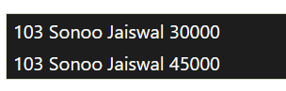

When JavaScript is used in HTML pages, JavaScript can **"react"** on these events JavaScript lets you execute code when events are detected.

HTML allows event handler attributes, **with JavaScript code**, to be added to HTML elements.

With single quotes:

<*element* *event*=**'*some JavaScript*'**>

With double quotes:

<*element* *event*=**"*some JavaScript*"**>

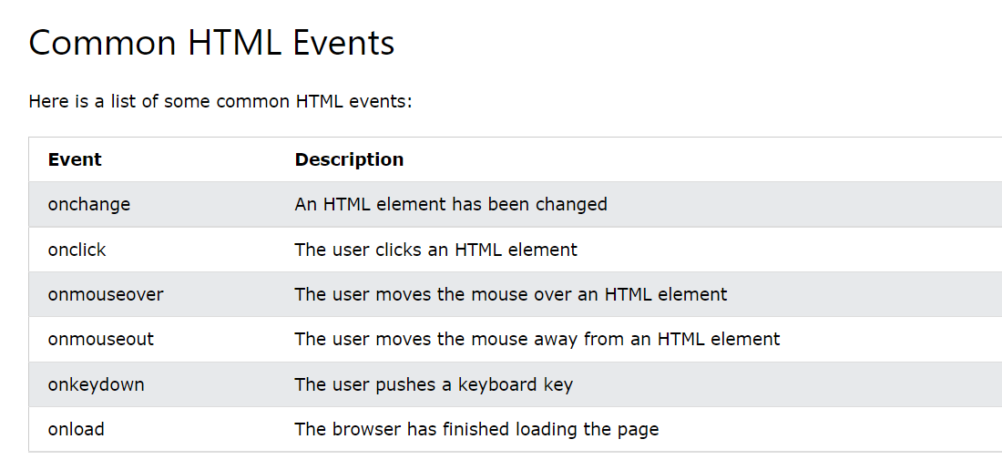

In the following example, an onclick attribute (with code), is added to a <button> element:

<!DOCTYPE html>

<html>

<body>

<button onclick="document.getElementById('demo').innerHTML=Date()">The time is?</button>

<p id="demo"></p>

</body>

</html>

**Output:**

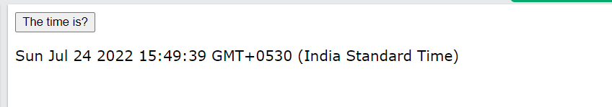

**19.** **Summarize how is Client side Java Script different from Server side Java Script?**

**Ans:**

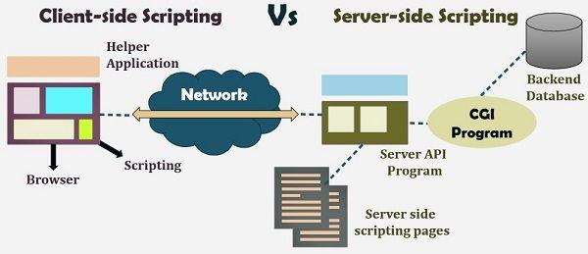

**Server-side scripting** is a technique of programming for producing the code which can run software on the server side, in simple words any scripting or programming that can run on the web server is known as server-side scripting. The operations like customization of a website, dynamic change in the website content, response generation to the user’s queries, accessing the database, and so on are performed at the server end.

The server-side scripting constructs a communication link between a server and a client (user). Earlier the server side scripting is implemented by the **CGI (Common Gateway Interface)** scripts. The CGI was devised to execute the scripts from programming languages such as C++ or Perl on the websites.

The server-side involves three parts: server, database, API’s and back-end web software developed by the server-side scripting language. When a browser sends a request to the server for a webpage consisting of server-side scripting, the web server processes the script prior to serving the page to the browser. Here the processing of a script could include extracting information from a database, making simple calculations, or choosing the appropriate content that is to be displayed in the client end. The script is being processed and the output is sent to the browser. The web server abstracts the scripts from the end user until serving the content, which makes the data and source code more secure.

#### **Server-side scripting languages:**

After the advent of CGI, multiple programming languages were evolved such as PHP, Python, Ruby, ColdFusion, C#, Java, C++ and so on for server-side scripting among which some of them are described below:

**PHP:** It is the most prevalent server-side language used on the web which was designed to extract and manipulate information in the database. The language is used in association with SQL language for the Database. It is used in Facebook, WordPress and Wikipedia.

**Python:** The language is fast and contains shorter code. It is good for beginners as it concentrates on the readability and simplicity of the code. Python functions well in the object-oriented environment and used in famous sites like Youtube, Google, etc.

**Ruby:** It contains complex logic which packages the back-end with database utility which can also be provided by PHP and SQL.

Client-side Scripting

**Client-side scripting** is performed to generate a code that can run on the client end (browser) without needing the server side processing. Basically, these types of scripts are placed inside an HTML document. The client-side scripting can be used to examine the user’s form for the errors before submitting it and for changing the content according to the user input. As I mentioned before, the web requires three elements for its functioning which are, client, database and server.

The effective client-side scripting can significantly reduce the **server load**. It is designed to run as a scripting language utilizing a web browser as a host program. For example, when a user makes a request via browser for a webpage to the server, it just sent the HTML and CSS as plain text, and the browser interprets and renders the web content in the client end.

#### **Client-side scripting languages:**

**HTML**: It is the fundamental building blocks of web programming which provides the frame to the website. It describes the arrangement of the content.

**CSS**: CSS provides the way to design the graphic elements which help in making the appearance of the web application more attractive.

**JavaScript**: It is also a client-side scripting language which essentially devised for the specific purpose, but currently there are various JavaScript frameworks used as server-side scripting technology.

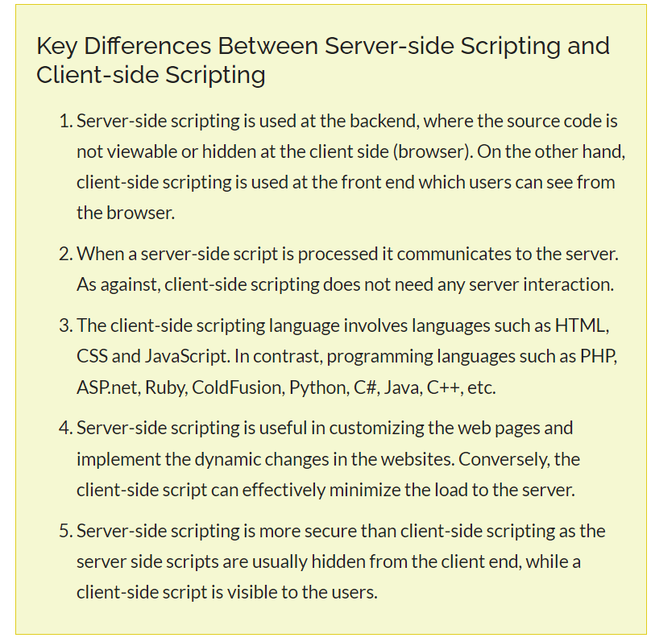

**20.Write short notes on Form Validation with an example**

**Ans:**

Form validation normally used to occur at the server, after the client had entered all the necessary data and then pressed the Submit button. If the data entered by a client was incorrect or was simply missing, the server would have to send all the data back to the client and request that the form be resubmitted with correct information. This was really a lengthy process which used to put a lot of burden on the server.

Through JavaScript, we can validate name, password, email, date, mobile numbers and more fields.

## **JavaScript Form Validation Example**

In this example, we are going to validate the name and password. The name can’t be empty and password can’t be less than 6 characters long.

Here, we are validating the form on form submit. The user will not be forwarded to the next page until given values are correct.

**<script>**

function validateform(){

var name=document.myform.name.value;

var password=document.myform.password.value;

if (name==null || name==""){

  alert("Name can't be blank");

  return false;

}else if(password.length**<6**){

  alert("Password must be at least 6 characters long.");

  return false;

  }

}

**</script>**

**<body>**

**<form** name="myform" method="post" action="abc.jsp" onsubmit="return validateform()"**>**

Name: **<input** type="text" name="name"**><br/>**

Password: **<input** type="password" name="password"**><br/>**

**<input** type="submit" value="register"**>**

**</form>**

**Output:**

